**Ultrafast Transient Absorption Measurements of Photocarrier Dynamics in PdSe2**

Guili Li,*a* Xiaoxian Zhang,*a* Yongsheng Wang,*a* Zhiying Bai,*a* Hui Zhao, *b* Jiaqi He*∗c* and Dawei He*∗a*

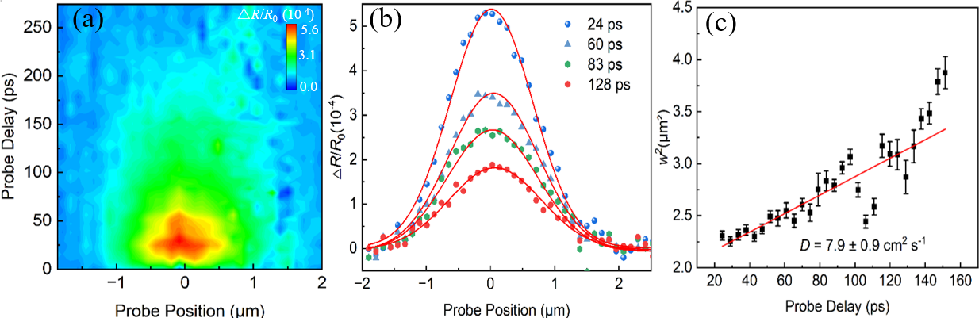

Fig.S1. Differential reflection signal of the bulk PdSe2 as a function of both the probe delay and the probe position. (b) Few examples of the spatial profiles of the differential reflection signal at probe delays as labeled in the figure. The red curves are Gaussian fits. (c) The squared width of the spatial profiles obtained by Gaussian fits as a function of the probe delay. The linear fit, shown as the red line, gives a diffusion coefficient of about 7.9 cm2 s−1.

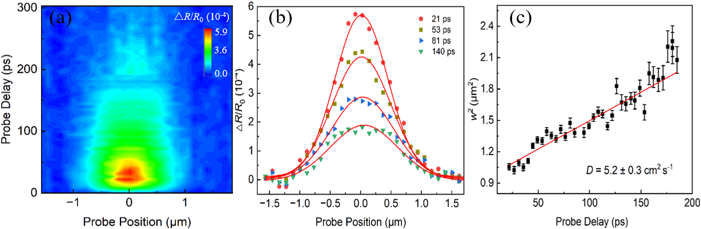

Fig.S2. Differential reflection signal of the bulk PdSe2 as a function of both the probe delay and the probe position. (b) Few examples of the spatial profiles of the differential reflection signal at probe delays as labeled in the figure. The red curves are Gaussian fits. (c) The squared width of the spatial profiles obtained by Gaussian fits as a function of the probe delay. The linear fit, shown as the red line, gives a diffusion coefficient of about 5.2 cm2 s−1.